**CAPSTONE PROJECT – UNIVERSITY SUCCESS ANALYSIS**

**GAURAV SHUKLA**

**OVERVIEW**

**The University Success Analysis project aims to identify key factors that influence student performance and graduation rates using data-driven insights. It examines academic performance, attendance, financial support, and extracurricular activities to determine their impact on student success.** **The project provides recommendations for students and universities to enhance retention, reduce dropouts, and improve academic success through early intervention strategies and personalized support systems.**

**THE PROCESS**

1. **Dataset Acquisition from GitHub:**

The dataset for this project was obtained from a GitHub repository, which contained student-related data in CSV and SQL formats. These files included key academic, attendance, financial, and engagement records, providing a foundation for analyzing factors influencing university success.

1. **Data Loading:**

The CSV file was imported into Excel for preliminary exploration, while the SQL file was loaded into MySQL for structured querying. This helped in understanding the data structure, identifying missing values, and preparing for further processing.

1. **Data Cleaning (ETL Process):**

To ensure data consistency and accuracy, an ETL (Extract, Transform, Load) process was performed. This involved removing duplicates, handling missing values, correcting data types, and normalizing records in Excel. The cleaned dataset was then structured for integration with analytical tools.

1. **Tool Integration:**

After data preparation, the refined dataset was connected to Excel, Power BI, and MySQL for deeper analysis and visualization. Excel was used for data manipulation, Power BI for interactive dashboards, and MySQL for advanced querying and data retrieval.

1. **Problem Definition & Insights Generation:**

Using Power BI, key problem statements were formulated to explore factors affecting university success. Various charts, graphs, and visual representations were created to analyze trends in academic performance, dropout rates, financial aid impact, and extracurricular participation. These insights provided a clear understanding of how different variables influence student success.

1. **Exploratory Data Analysis (EDA):**

An in-depth Exploratory Data Analysis (EDA) was conducted using Excel and SQL to uncover patterns and correlations. SQL queries helped in filtering data, performing statistical analysis, and drawing relationships between student engagement, financial stability, and academic achievements. Excel’s pivot tables and statistical tools further refined these insights.

1. **Presentation & Reporting:**

Finally, the key findings, insights, and recommendations were compiled into a PowerPoint presentation. This report effectively summarized the analysis with graphs, tables, and actionable suggestions for improving university success rates.

1. **Detail Documentation:** Compile a detailed report that meticulously documents the entire project lifecycle.Include sections on data collection,transformation,problem statement formulation,toll integration,Power BI solution,EDA insights and Powerpoint visualizations.

**OBJECTIVE**

The primary objective of this project is to identify and analyze the key factors that contribute to university student success. These factors include academic performance, student-staff ratio, financial stability, extracurricular involvement, faculty engagement,ranking system. By understanding how these variables affect student outcomes, universities can implement targeted strategies to improve graduation rates and overall academic achievement.

The project will involve the following task:

* Performing a comprehensive analysis of university ranking,including variations across systems,key factor influencing rankings,historical trends and the impact of limitations and biases on rankings.
* Derving meaningful conclusions and recommendations for improving methodologies.
* Compiling analysis results,conclusions and recommendations for stakeholders.

The success of the project will be measured by the following metrics:

* The quality of the analysis
* The relevance of the insights
* The Impact of the recommendations.

This project is significant because it has the potential to improve the quality and competitiveness of higher education institutions worldwide.By understanding the factors that influence university rankings,institutions can better position themselves to succeed in the global marketplace.

**SIGNIFICANCE**

The significance of this project lies in its ability to provide universities, policymakers, and educational institutions with data-driven insights that enhance decision-making processes. A key aspect of this study includes an analysis of university rankings across different countries, using a dataset that contains country names, university IDs, and ranking systems. Understanding how various factors contribute to university success on a global scale can help institutions benchmark their performance against others and implement best practices.

By studying ranking trends, institutions can identify the areas where they excel and those requiring improvement. Factors such as faculty-to-student ratio, research output, student satisfaction, and employability rates play a crucial role in ranking determination. This analysis also helps universities tailor their strategies to improve rankings, attract international students, and secure funding for academic development. Moreover, governments and education boards can use these insights to formulate policies that support higher education institutions in their respective countries.

Through data visualization and analytical models, this project enables universities to pinpoint the exact elements that contribute to their success or decline in rankings. Universities can implement strategic interventions such as enhancing curriculum quality, increasing research investments, and strengthening faculty development programs. Additionally, students can benefit from this analysis by selecting universities that align with their academic and career goals based on rankings and success metrics.

**DATA DICTIONARY**

**Country Table -** In this country table contains dataset and providing fundamental geographic context.

1.ID: A unique identifier assigned to each country.

2Country Name: Name of each country.

**University Table -** This table catalogs universities featured in the ranking systems with each institution linked to a specific country.

1.ID : Unique identifier for each country.

2.Country ID : Identifier of the country to which the university belongs.

3.University name : Name of the University.

**Ranking System -** This contains the three different ranking systems used: Times Higher Education World University Ranking, Shanghai Ranking, and Center for World University Rankings.

1.ID: Unique Identifier for each ranking system.

2.System Name: Name of each ranking system.

**Ranking Criteria -** This table contains the different criteria used in each ranking system, such as Citations and Quality of Education. It also contains criteria for Total Score for each system.

1.ID: Unique identifier for each ranking criterion.

2.Ranking system ID: Id of ranking system.

3.Criteria Name: Name of each critria.

**University Year -** The university_year table contains values for measurements such as the number of students and the student to staff ratio for each university in several years.

1. University Id: Id of the university.

2.year: Year of observation.

3.Num_students: Total number of students in the university.

4.Student_staff_ratio: Student to staff ratio of each university.

5.Pct_international_students: Total percentage of international students in each country.

6.Pct_female_students: Total percentage of female students in each country.

**University Ranking Year** - This extensive table furnishes score for each university across various years and ranking criteria serving as the primary repository of ranking data.

1. University Id: Id of university.

2.Ranking criteria id: Id of ranking criteria.

3. year: Year of assessment.

4.Score: Score of each university

**ER DIAGRAM**

***POWER BI PROBLEM STATEMENT***

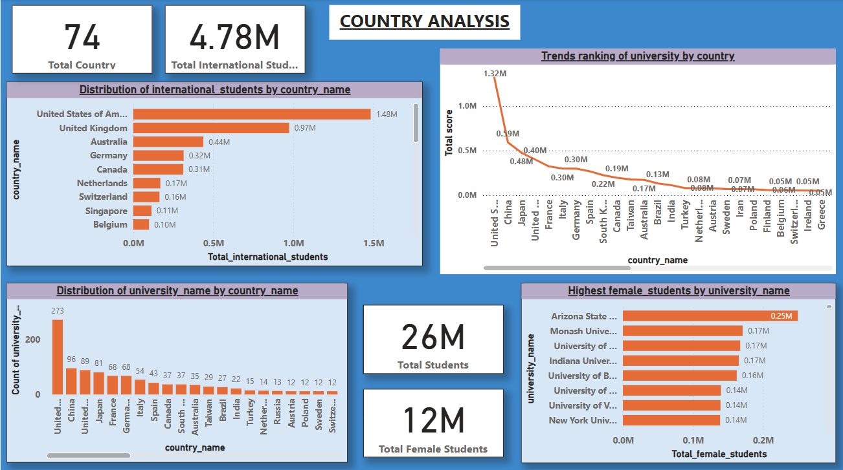

**How many universities are there in each country?**

The bar chart displays the distribution of universities across various countries, with the United States leading significantly (273 universities), followed by China (96) and the United Kingdom (89). Other notable countries include Japan (81), Germany (68), France (54), and Italy (43). Mid-range countries like Canada, Spain, South Korea, and Australia have between 30-60 universities, while nations like India, Brazil, Turkey, and several European countries have fewer than 30. The data highlights a strong concentration of universities in a few countries, with a mix of quantity vs. quality approaches among nations. The United States dominates in the number of universities, reflecting its extensive education system. Countries like China, the UK, Japan, and Germany also maintain strong university networks. While some large-population countries like India and Brazil have relatively fewer universities, European nations prioritize quality over quantity. The data suggests a global divide in higher education systems, with some countries focusing on expansion while others emphasize selectivity and reputation.

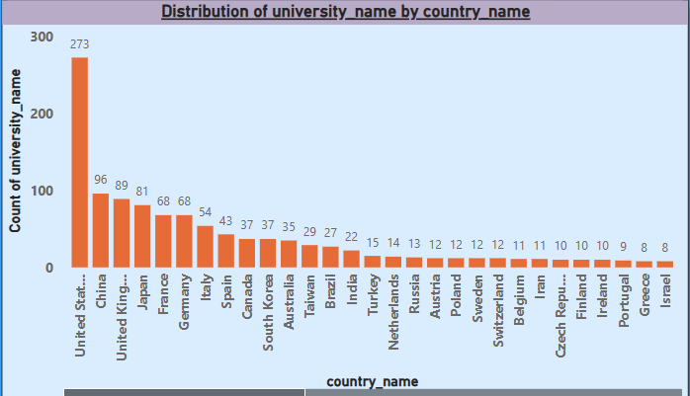

**What is the distribution of international students across different countries?**

The United States (1.48M) and the United Kingdom (0.97M) lead as the most popular study destinations for international students, followed by Australia, Germany, and Canada. European nations have varying levels of attractiveness, with Germany, the Netherlands, and Switzerland having significant numbers. In contrast, countries like South Korea, Spain, and Turkey attract relatively fewer students, while Russia, Italy, and Egypt have the lowest numbers. The dominance of English-speaking countries in international education highlights the importance of language accessibility, global reputation, and funding opportunities in attracting students. Countries like Germany provide tuition-free education, making them competitive despite language barriers. Meanwhile, nations with fewer international students might need to improve global outreach, scholarships, or education policies to attract a larger student base.

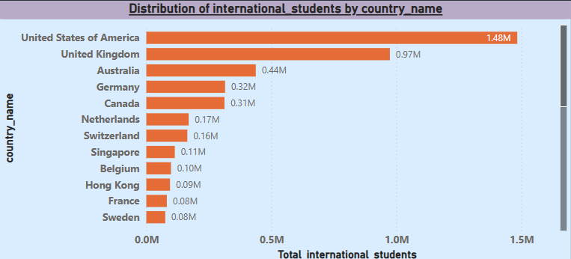

**Which country has the highest number of female students enrolled in universities? 4 How many universities are ranked by each ranking system?**

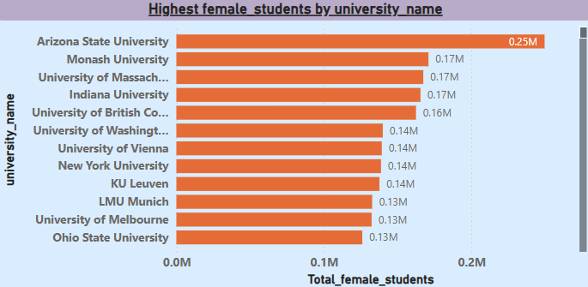Arizona State University has the highest number of female students, with 0.25 million, followed by Monash University, the University of Massachusetts, and Indiana University, each with 0.17 million female students. Other universities, such as the University of British Columbia (0.16M), University of Washington (0.14M), and New York University (0.14M), also have significant female student populations. Ohio State University, the University of Melbourne, and LMU Munich rank at the lower end of this list, each with 0.13 million female students. The data indicates that Arizona State University leads in female student enrollment, significantly outpacing other institutions. Universities from the U.S., Australia, Canada, and Europe dominate the list, suggesting that these regions provide strong educational opportunities for women. The relatively high female student numbers highlight growing gender inclusivity and access to higher education, although further analysis would be needed to assess gender ratios compared to total student enrollment.

**Are there any significant trends or patterns in the rankings of universities from different countries?**

The United States (1.32M) leads in university rankings, followed by China (0.59M), Japan (0.48M), and the UK (0.40M). France, Germany, and Italy also have strong rankings, while Spain, South Korea, and Canada rank in the mid-tier. India, Brazil, and Australia have moderate scores, but several European, Middle Eastern, and African countries have lower-ranked universities, indicating room for improvement. The dominance of the U.S. and top European countries highlights their investment in research, innovation, and education quality. Meanwhile, China and Japan are emerging as strong competitors. To enhance global rankings, lower-ranked countries must improve research output, international collaborations, and university funding to compete with leading education hubs.

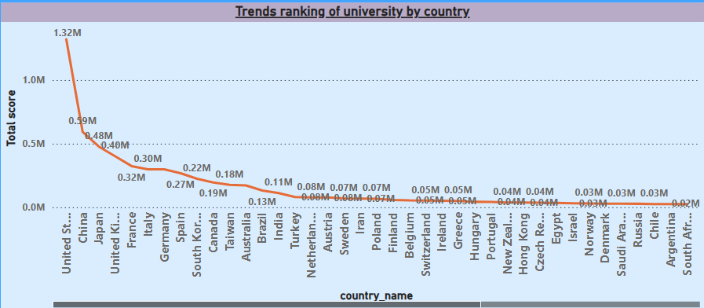

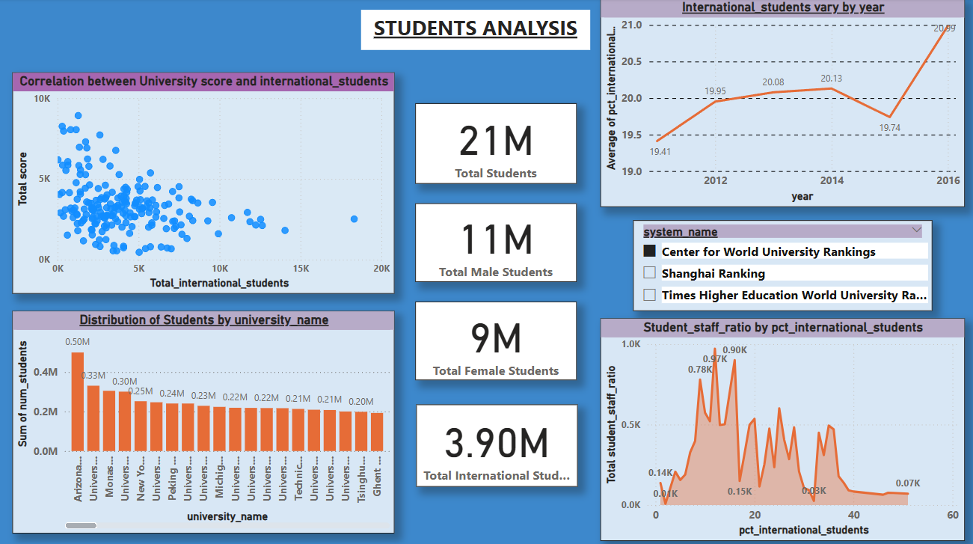

**Is there a correlation between a university's score and the number of international students?**

The scatter plot illustrates the correlation between university scores and the number of international students. The data points show a wide dispersion, indicating no strong linear relationship between the two variables. While some universities with higher total scores have a significant number of international students, others with high scores have fewer international students, suggesting that a university’s ranking does not directly depend on international student enrollment. The analysis suggests that a university’s total score is not strongly correlated with the number of international students. While some top-ranking universities attract many international students, others maintain high rankings with fewer international enrollments. Other factors, such as research output, faculty reputation, funding, and academic programs, likely contribute more to a university’s total score than just the number of international students.

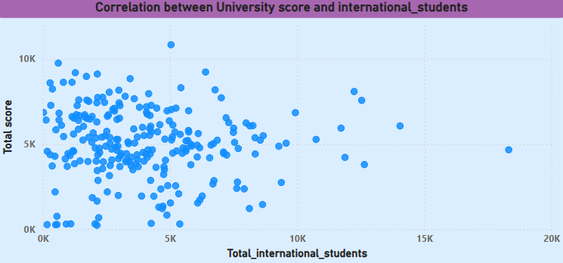

**Which university has the highest number of students?**

The bar charts show the distribution of students by university, with Arizona State University leading with 0.50 million students, followed by other large universities such as Indiana University (0.34M), Monash University (0.31M), and Pennsylvania State University (0.30M). The student population among universities gradually decreases, with several institutions having between 0.19M and 0.15M students, including Ghent University, RWTH Aachen University, and National University of Singapore. The data highlights a significant variation in student populations across universities, with some institutions having substantially larger enrollments. Arizona State University stands out with the highest student count, indicating its large-scale academic programs and capacity. Universities in the U.S., Europe, and Asia dominate the list, reflecting their global appeal and strong academic infrastructure. The variation in student numbers suggests differences in university sizes, program offerings, and student intake capacities across regions.

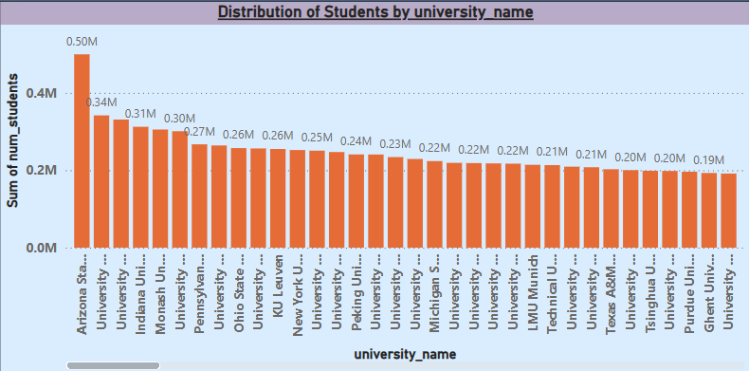

**How does the percentage of international students vary across different years?**

The line chart displays the percentage of international students over the years from 2011 to 2016. The trend generally shows an increase in international student enrollment, rising from 19.31% in 2011 to 19.93% in 2014. However, there was a decline in 2015 to 19.42%, followed by a sharp rise to 20.69% in 2016, marking the highest percentage in the given period. The data indicates a growing trend in international student enrollment, despite a slight dip in 2015. The sharp increase in 2016 suggests improved policies, better university outreach, or rising global mobility for education. This trend highlights the increasing globalization of higher education, with universities attracting more international students over time.

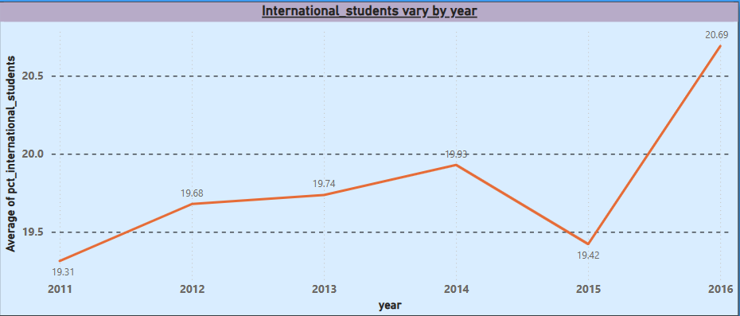

**How does the percentage of international students affect a university's student-staff ratio?**

The graph shows the student-staff ratio in relation to the percentage of international students. The trend exhibits high fluctuations, with peaks around 10-20% international students, where the student-staff ratio exceeds 1.5K at certain points. As the percentage of international students increases beyond 30%, the student-staff ratio declines significantly, stabilizing at lower levels. There appears to be a higher student-staff ratio when the percentage of international students is between 10-20%, indicating potential resource constraints in universities during this range. However, as the proportion of international students increases beyond 30%, the student-staff ratio drops, suggesting better resource allocation or more faculty recruitment in globally diverse institutions.

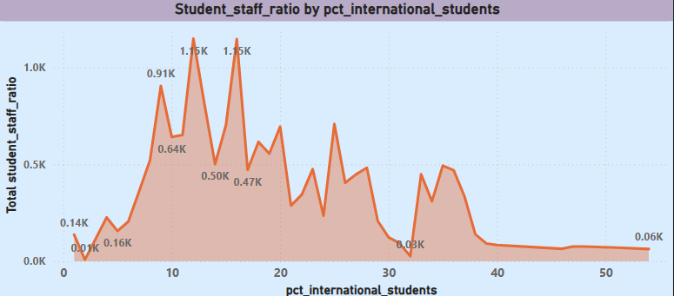

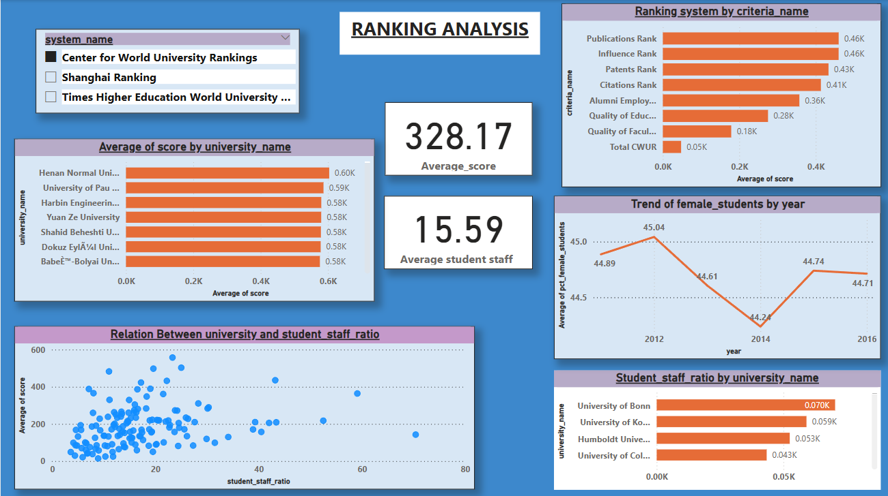

**What is the average score for universities according to each ranking system?**

The bar chart displays the average scores of universities, with Henan Normal University having the highest score at 0.60K, followed closely by the University of Pau and Pays de l'Adour (0.59K) and Harbin Engineering University (0.58K). The scores of all listed universities are very close, ranging between 0.57K and 0.60K. The small variation in scores among the universities suggests a relatively even academic performance across institutions. However, Henan Normal University stands out slightly with the highest score, indicating a marginally better performance compared to the others.

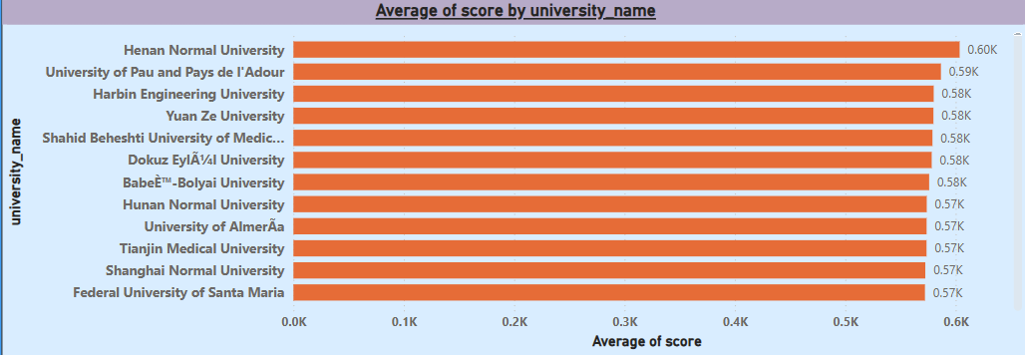

**How does the ranking system affect a university's student-staff ratio?**

The bar chart presents the student-staff ratio across universities, with the University of Bonn having the highest ratio at 0.070K, followed by the University of Konstanz (0.059K) and Humboldt University (0.053K). Other universities show relatively lower student-staff ratios, with the lowest being The University of Queensland at 0.033K. A higher student-staff ratio suggests that each staff member is responsible for more students, potentially indicating larger class sizes and limited individual attention. The University of Bonn has the highest ratio, which might imply higher academic workload per staff member, while The University of Queensland has the lowest ratio, suggesting more faculty availability per student and potentially better student support.

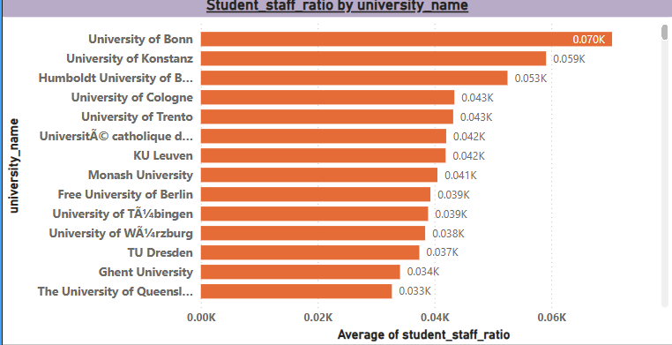

**What are the most important criteria considered by ranking systems?**

The ranking system is primarily influenced by Publications Rank and Influence Rank, both scoring 0.46K, followed closely by Patents Rank (0.43K) and Citations Rank (0.41K). Other factors such as Alumni Employment Rank (0.36K) and Quality of Education Rank (0.28K) play a significant role, while Income (0.05K) and International presence (0.06K) contribute the least. Research output (publications, patents, and citations) is the dominant factor in university rankings. Employment-related metrics and education quality also hold weight, while financial and international factors have a minimal impact on rankings.

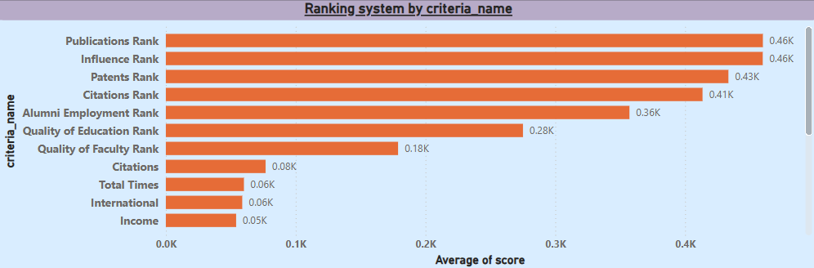

**How does the percentage of female students impact a university's ranking?**

The percentage of female students showed an upward trend from 2011 (45.28%) to 2012 (45.53%), followed by a steady decline reaching its lowest point in 2014 (44.5%). Afterward, the trend reversed, with a gradual increase reaching 45.25% in 2016. The trend of female student enrollment experienced fluctuations, with a peak in 2012 and a dip in 2014 before rebounding. The overall trend suggests that while there were temporary declines, the percentage of female students remained relatively stable over the years.

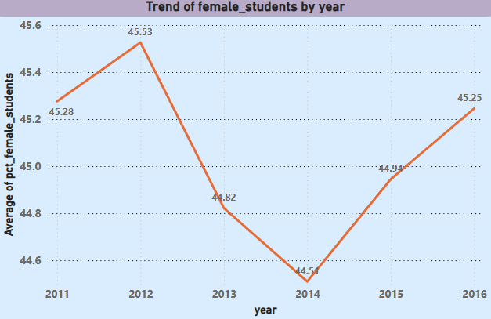

**Is there a correlation between a university's ranking and its student-staff ratio?**

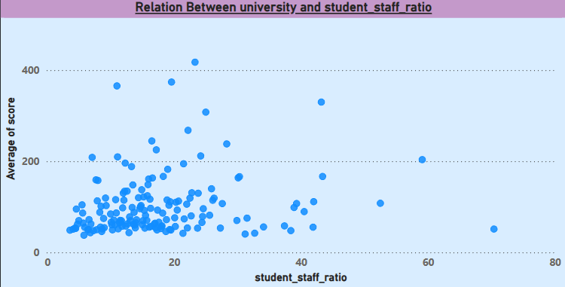The scatter plot displays the relationship between the student-staff ratio and the average university score. The majority of universities have a student-staff ratio below 30, with their scores ranging from low to high. As the student-staff ratio increases, the density of universities decreases, indicating that fewer universities operate with high student-to-staff ratios. Some outliers are visible, where universities with a low student-staff ratio (below 20) achieve high scores (above 300-400), suggesting that smaller class sizes may contribute to better institutional performance. However, universities with higher student-staff ratios tend to have more dispersed and generally lower scores. The trend suggests a negative correlation between the student-staff ratio and university scores, meaning that universities with a lower student-staff ratio tend to have better scores. This may indicate that institutions with better faculty-to-student engagement can provide higher-quality education, leading to better academic performance. However, the presence of some high-scoring universities with higher student-staff ratios suggests that other factors, such as funding, research output, and institutional reputation, also contribute to overall performance.

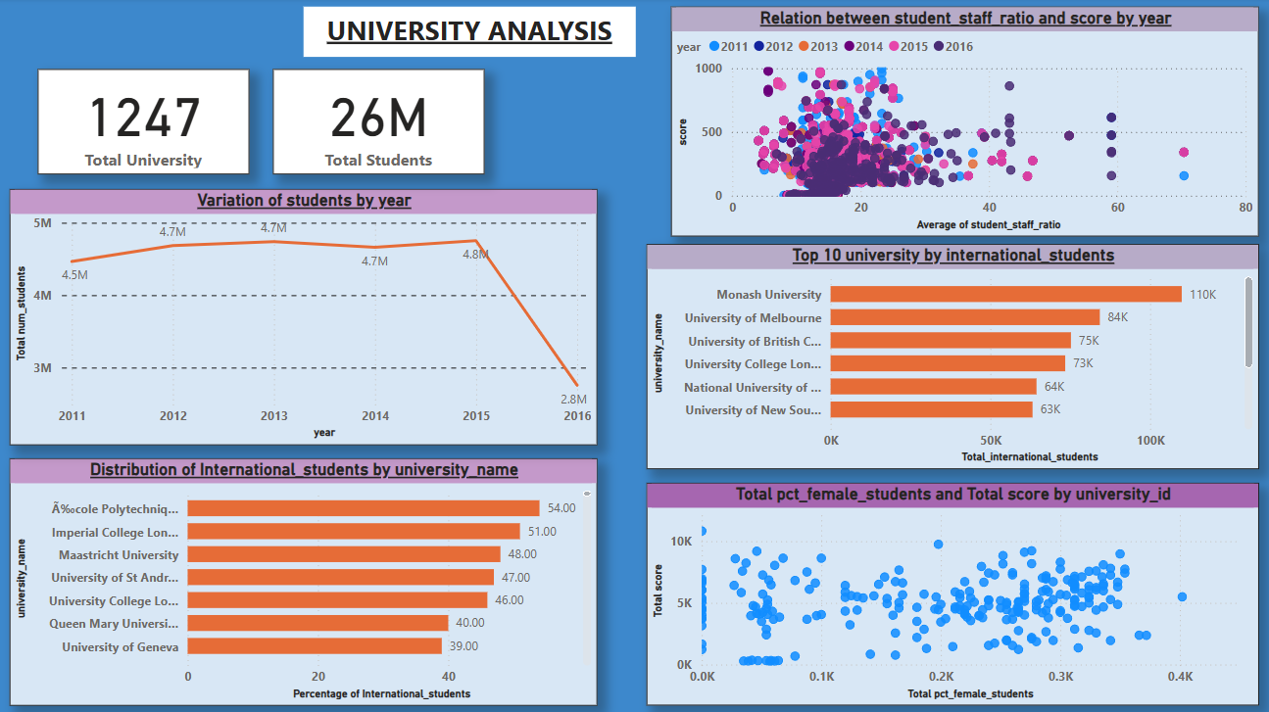

**How does the percentage of international students vary across different universities?**

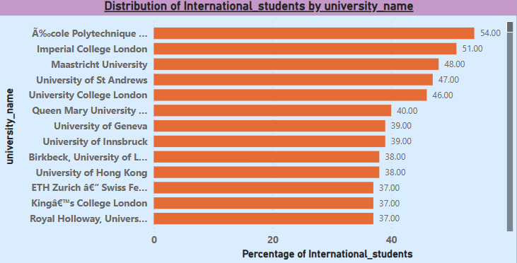The bar chart presents the distribution of international students across various universities based on their percentage representation. École Polytechnique has the highest percentage of international students at 54%, followed by Imperial College London (51%) and Maastricht University (48%). Several universities, including University of St Andrews (47%), University College London (46%), and Queen Mary University (40%), also have a significant international student population. Other institutions, such as University of Geneva and University of Innsbruck (both 39%), University of Hong Kong (38%), and ETH Zurich (37%), maintain a strong international presence as well. The data indicates that many top-ranking universities attract a substantial number of international students, particularly those in the UK, Switzerland, and Hong Kong. This suggests that these institutions offer a globalized education environment, strong research opportunities, and internationally recognized programs. Universities with higher percentages of international students likely benefit from diverse perspectives, cultural exchanges, and increased global networking opportunities. Institutions with a lower proportion of international students might focus more on domestic enrollment or have fewer programs tailored for international applicants.

**How does the number of students in universities change over time?**

The line graph illustrates the variation in the total number of students over the years from 2011 to 2016. The student population started at 4.46 million in 2011 and showed a gradual increase, peaking at 4.75 million in 2015. However, there was a sharp decline in 2016, where the number of students dropped drastically to 2.75 million, indicating a major reduction in student enrollment. The trend suggests that student enrollment was relatively stable and increasing until 2015, showing a positive trajectory. However, the significant drop in 2016 may indicate external factors such as policy changes, funding cuts, economic shifts, or changes in admission criteria that drastically impacted student enrollment. Further analysis is needed to determine the specific reasons behind this sudden decline.

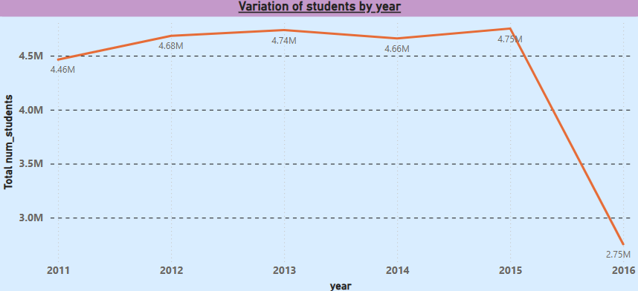

**Is there a correlation between a university's ranking score and the student-staff ratio over the years?**

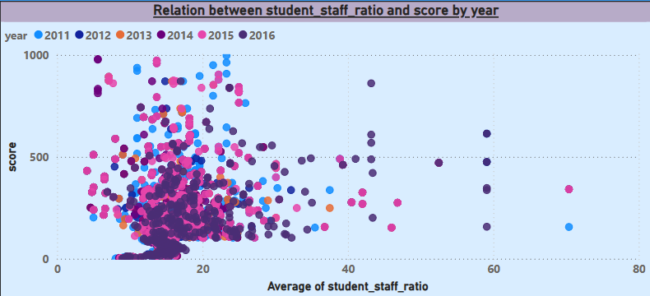The scatter plot illustrates the relationship between student-staff ratio and score from 2011 to 2016. The majority of data points are concentrated at lower student-staff ratios (below 20), with varying scores. There are a few instances where universities have higher student-staff ratios (above 40), but they tend to have lower scores. The color-coded points indicate that this trend is consistent across different years. The graph suggests a negative correlation between student-staff ratio and score—as the student-staff ratio increases, the score tends to decrease. This implies that universities with a lower student-staff ratio (more staff per student) generally achieve higher scores, which could indicate better academic support and faculty availability. Institutions with higher student-staff ratios may struggle to maintain high scores, possibly due to limited faculty resources.

**What is the impact of a university's ranking on the number of international students it attracts?**

The bar chart displays the top 10 universities with the highest number of international students. Monash University leads the ranking with 110K international students, followed by the University of Melbourne (84K) and the University of British Columbia (75K). Other notable institutions include University College London (73K) and the National University of Singapore (64K). The lowest in the top 10 is the University of Vienna with 52K international students. The chart highlights the significant presence of international students in these universities, indicating their global appeal and strong international student support systems. Australian, British, Canadian, and Singaporean institutions dominate the list, suggesting that these countries are major education hubs. Monash University stands out as the leading university in attracting international students, likely due to its diverse academic programs, global collaborations, and student-friendly policies.

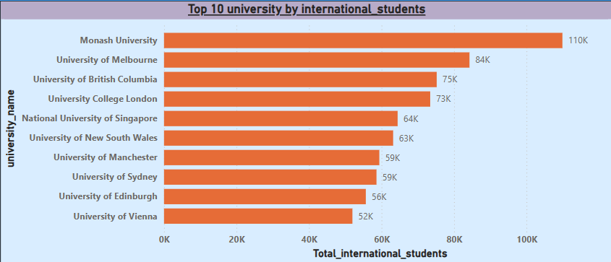

**Is there a relationship between a university's ranking score and the percentage of female students enrolled?**

The scatter plot visualizes the relationship between the total percentage of female students and the total score by university. The data points show a scattered distribution, indicating no clear linear correlation between the percentage of female students and the total score. Some universities with a higher percentage of female students have both high and low scores, suggesting that other factors influence a university's total score beyond gender diversity. The chart suggests that while gender diversity in universities is an important metric, it does not directly correlate with the institution's overall score. Other factors, such as faculty quality, research output, and funding, may play a more significant role in determining university rankings. However, institutions with a balanced gender ratio may still benefit from a diverse academic environment, enhancing inclusivity and innovation.

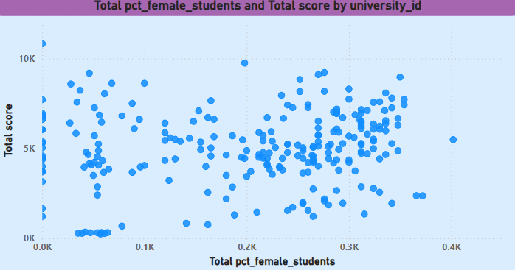

**EDA PROBLEM STATEMENT**

**Is there a correlation between a country's GDP and the number of universities?**

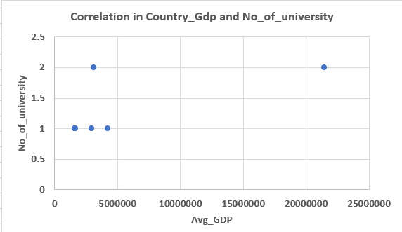The scatter plot illustrates the relationship between a country's average GDP and the number of universities. The data points appear widely scattered, suggesting a weak or no clear correlation between GDP and the number of universities. Some countries with lower GDP have a similar number of universities as those with higher GDP, indicating that factors other than economic strength may influence university presence. While GDP is an important indicator of a country's economic capacity, it does not directly determine the number of universities. Other factors such as government policies, education funding, population size, and historical academic institutions may play a significant role. A deeper analysis with a larger dataset might be needed to draw a more definitive conclusion.

**How has the number of universities changed over the years in each country?**

The bar chart represents the number of universities by year, showing significant fluctuations in the data. The years 2013, 2014, and 2015 experienced sharp spikes, indicating a surge in the establishment or reporting of universities during these periods. Other years show a relatively lower number of universities, with some years barely registering any institutions. The sudden peaks in 2013, 2014, and 2015 suggest that there may have been specific policy changes, reforms, or increased investments in higher education that led to a rapid increase in university establishments during these years. The lower numbers in other years indicate a more stable or slower rate of university creation. Further investigation into government policies, education funding, and global trends during these peak years might provide better insights into the observed variations.

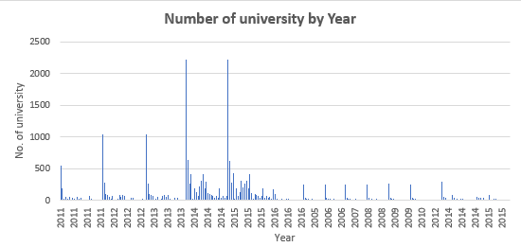

**Is there a relationship between a country's population and the number of universities?**

The scatter plot visualizes the correlation between population and the number of universities in different regions or countries. The data points indicate that there is no clear linear relationship between population size and the number of universities. Some regions with a lower population have the same or even more universities than regions with a significantly higher population. The absence of a strong correlation suggests that the number of universities is not solely dependent on population size. Other factors such as government policies, economic strength, education funding, and demand for higher education likely play a more significant role in determining the number of universities in a given region. Further analysis, incorporating factors like GDP, literacy rates, and educational policies, could provide deeper insights into the underlying trends.

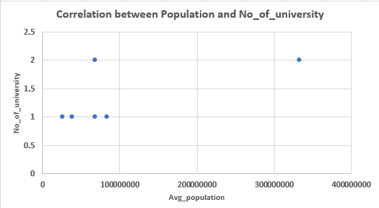

**Are there any common criteria used by different ranking systems?**

The bar chart illustrates the number of ranking criteria used by different university ranking systems. The Center for World University Rankings employs the highest number of criteria (8), followed by the Shanghai Ranking with 7 criteria, and the Times Higher Education World University Ranking with 6 criteria. This comparison highlights the differences in evaluation methodologies among these global ranking systems. The variation in the number of ranking criteria suggests that each ranking system prioritizes different aspects of university performance. Institutions and students should consider these differences when interpreting rankings, as some systems may focus more on research output, faculty quality, or student experience than others. A deeper analysis of the specific criteria used could provide better insights into how universities are evaluated globally.

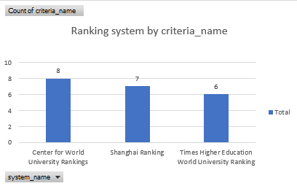

**What is the trend in university rankings over the years according to each system?**

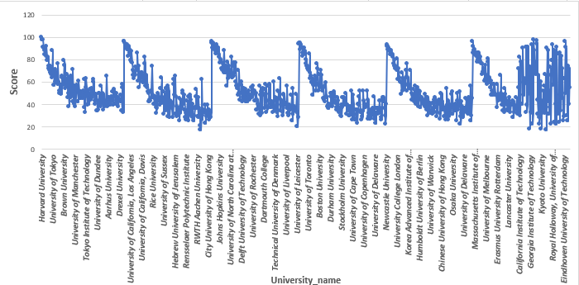The line chart visualizes the scores of various universities, showing fluctuations in scores across different institutions. The trend indicates that some universities consistently achieve higher scores, while others have more variability, suggesting differences in performance metrics or ranking criteria. The variation in scores across universities highlights disparities in academic performance, research output, and institutional quality. The distinct groupings in the chart may reflect ranking tiers, where certain universities consistently outperform others. This suggests that university rankings are influenced by multiple factors, and institutions striving for higher scores may need to focus on research excellence, faculty quality, and global impact.

**How does the choice of ranking system affect a university's international student enrollment?**

The pie chart represents the distribution of international students across different university ranking systems. The Times Higher Education World University Ranking accounts for 27,247 students, the Shanghai Ranking includes 25,291 students, and the Center for World University Rankings has 20,536 students. The Times Higher Education World University Ranking attracts the highest number of international students, followed closely by the Shanghai Ranking, while the Center for World University Rankings has the lowest share. This suggests that students may prefer universities ranked higher in Times Higher Education, possibly due to its influence, methodology, or global reputation.

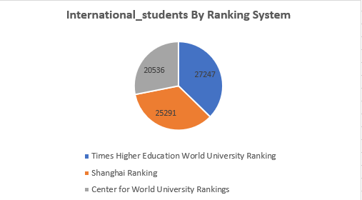

**Are there any criteria that have different weights in different ranking systems?**

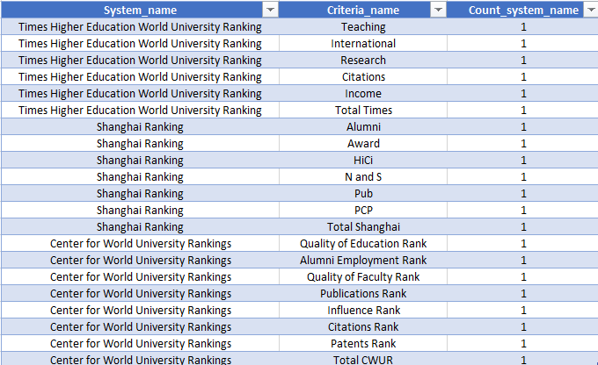The table presents three major university ranking systems—Times Higher Education World University Ranking, Shanghai Ranking, and Center for World University Rankings (CWUR)—and the criteria they use to evaluate universities. Each ranking system has unique evaluation parameters, such as Teaching, Research, and Internationalization (Times Higher Education), Alumni, Awards, and Publications (Shanghai Ranking), and Quality of Education, Faculty, and Citations (CWUR). Each ranking system emphasizes different aspects of university performance, leading to varying ranking outcomes. Times Higher Education focuses on academic performance and income, Shanghai Ranking on research excellence and alumni achievements, and CWUR on education quality and faculty reputation. This variation suggests that universities may perform differently depending on the ranking system used, making it important to consider multiple rankings for a holistic evaluation

**How have the weights of ranking criteria changed over time?**

The bar chart illustrates the number of ranking criteria used over the years from 2005 to 2016. There is a gradual increase in the number of criteria used up until 2013, followed by a sharp rise in 2014 and 2015, where the criteria reached their peak. However, in 2016, the number of criteria dropped significantly. The trend suggests that university ranking systems progressively introduced more criteria over time, especially with a major expansion in 2014 and 2015. The sudden decline in 2016 could indicate a shift in ranking methodologies, consolidation of criteria, or a change in the ranking approach. This evolution highlights the dynamic nature of ranking systems and the continuous refinement of university evaluation methods.

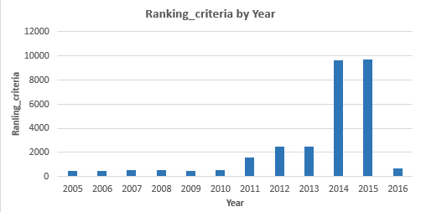

**Is there a relationship between a university's score and the student-staff ratio?**

The scatter plot visualizes the relationship between university scores and student-staff ratios. The data shows a positive correlation, indicating that universities with higher total scores tend to have a higher student-staff ratio. However, there is noticeable dispersion, suggesting variations in how universities balance faculty resources and student population.While a higher university score generally corresponds to a higher student-staff ratio, the wide distribution suggests that other factors influence rankings beyond just faculty size. Universities with lower student-staff ratios might offer better individual attention but may not always rank the highest, emphasizing that institutional reputation and resources also play key roles in university scoring.

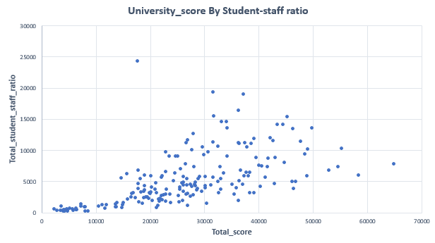

**How does the number of female students differ among universities?**

The bar chart represents the total percentage of female students across various universities. The University of Vienna, University of Copenhagen, and Vanderbilt University have the highest number of female students, while Tel Aviv University and National Chiao Tung University have the lowest.

There is a noticeable variation in female student representation across universities. Some institutions show higher female enrollment, possibly due to academic programs, cultural factors, or institutional policies that encourage female participation. Universities with lower female representation might need to implement initiatives to improve gender diversity.

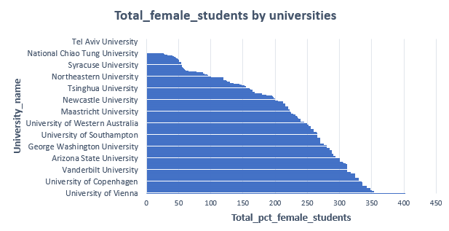

**What is the distribution of universities across different countries?**

The bar chart illustrates the total number of universities in different countries. The United States has the highest number of universities, followed by Japan, Italy, France, and South Korea. Other countries have significantly fewer universities in comparison.

The distribution of universities varies widely across countries, with the United States leading by a large margin. This indicates a strong higher education infrastructure in the U.S. compared to other nations. Countries with fewer universities may have more centralized or selective education systems or lower overall demand for higher education institutions.

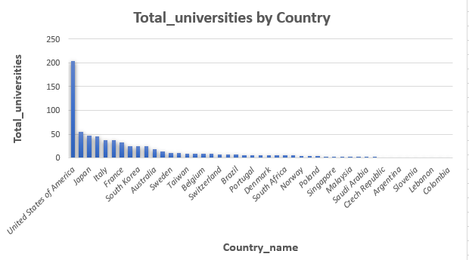

**How has the ranking of universities changed over the years?**

The horizontal bar chart displays the total scores of various universities, with Harvard University achieving the highest total score, followed by other well-known institutions like the University of Chicago and McMaster University. Some universities have significantly lower scores compared to the top-ranked institutions.The variation in total scores among universities highlights the differences in academic performance, research impact, and institutional quality. Prestigious universities tend to score higher, indicating their stronger reputation, faculty, and resources, while others may have room for growth in these areas.

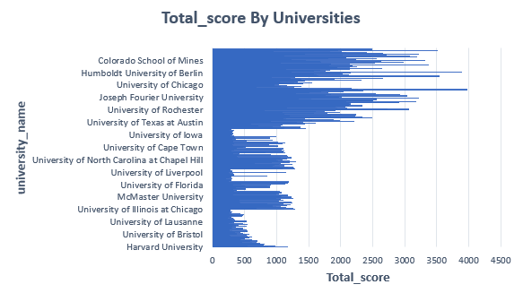

**What is the trend in the percentage of female students over time?**

The bar chart illustrates the percentage of female students across various universities over multiple years. The majority of universities report an average female student percentage between 40% and 70%, suggesting a relatively balanced gender ratio. However, some universities exhibit noticeable fluctuations, with certain institutions experiencing a wider range of female enrollment percentages, possibly due to variations in academic programs, cultural factors, or historical trends in gender representation in higher education.

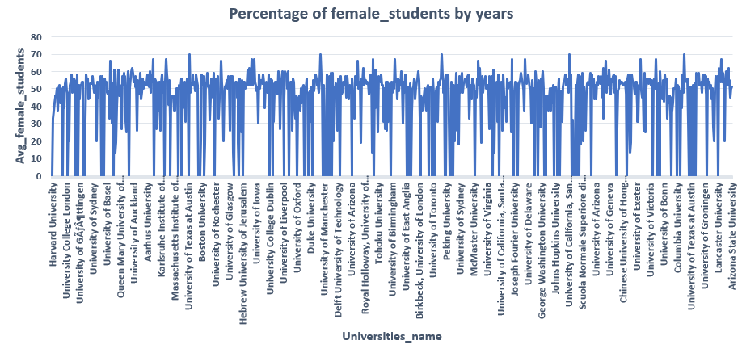The data indicates that many universities have achieved a significant level of gender diversity in student enrollment, with female representation consistently present in most institutions. However, the variability in percentages across universities suggests that some institutions may still face gender disparities, particularly in specific fields of study that have traditionally seen lower female participation. This highlights the need for continued efforts to promote gender inclusivity in higher education, especially in historically male-dominated disciplines.

**How has the ranking score of universities evolved over the years?**

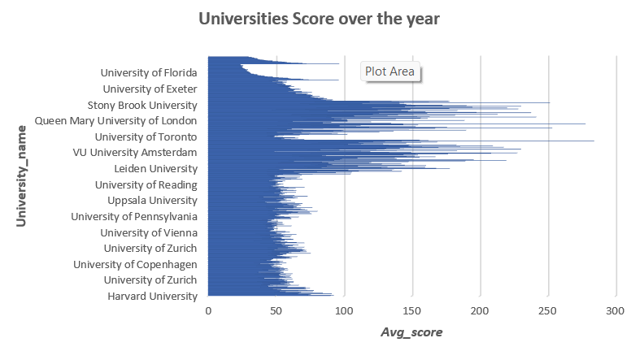The horizontal bar chart illustrates the average scores of various universities over the years. The distribution of scores varies significantly, with some universities exhibiting a wider range of scores, suggesting fluctuations in their performance over time. In the year 2005 till 2016 The Top Global University are Harvard University ranks highest with an Avg_Score of 96 are rapidly increases or decrease within these years. Some Elite Group: The top 5 universities include Harvard, Cambridge, Stanford, UC Berkeley, and Caltech, all scoring above 67 are consistently Strong performers. Leading Universities: MIT (92.5), Imperial College London (90.83), and Johns Hopkins University (84.33) show strong global standings. Oxford and Stanford (both 53.24) hold strong global positions. Princeton (65.19), Cambridge (56.24), and MIT (49.00) are among the best. The data suggests that some universities maintain consistently high scores, reflecting strong academic performance and institutional reputation. However, others show greater variability, indicating periods of fluctuations in ranking and performance. This variation could be attributed to changes in faculty quality, research output, funding, or student performance over time. Understanding these trends is crucial for universities to improve their strategies and maintain or enhance their academic standing.

**Is there a relationship between a university's ranking score and the number of students over time?**

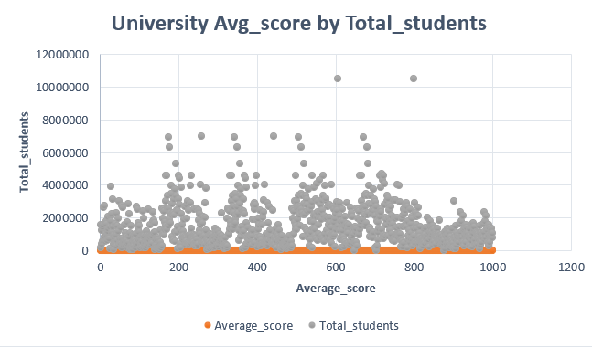The Scatter graph plots universities based on their Average Score (x-axis) and Total Students (y-axis).Each grey dot represents a university's student population in relation to its average score. Most universities have low average scores, clustered around the lower end of the x-axis.There are some universities with high student populations, as seen in the scattered high points on the y-axis.The distribution is uneven, meaning some universities have significantly larger student populations but do not necessarily have higher average scores.Universities with higher average scores may not always have a large number of students.Some outlier universities have exceptionally high student populations.There may not be a strong correlation between the total number of students and the average score. There is no strong relationship between university average scores and total student enrollment, suggesting that larger universities do not necessarily have higher or lower scores. This could be due to differences in academic quality, faculty-to-student ratios, research output, or ranking methodologies that are not solely dependent on student numbers. Further analysis may be needed to determine what factors impact university scores more significantly.

**CONCLUSION**

The **University Success Analysis Project** provides valuable insights into the key factors influencing student success and university rankings. By leveraging **data analytics, visualization tools, and predictive models**, this project helps institutions develop **evidence-based strategies** to improve academic performance, student retention, and overall institutional success. The findings demonstrate the importance of **financial support, faculty engagement, and extracurricular activities** in fostering a comprehensive learning environment. Moreover, by examining global ranking systems, universities can **benchmark their performance and adopt best practices** from leading institutions worldwide. Implementing **data-driven policies** and targeted interventions will enable universities to **enhance student outcomes, optimize academic resources, and strengthen their reputation**. Moving forward, expanding the dataset to include a more diverse range of institutions and implementing **real-time analytics dashboards** can further improve the impact of this research. Ultimately, this project serves as a foundation for **higher education institutions to embrace data-driven decision-making and create an environment where students can thrive academically and professionally**.